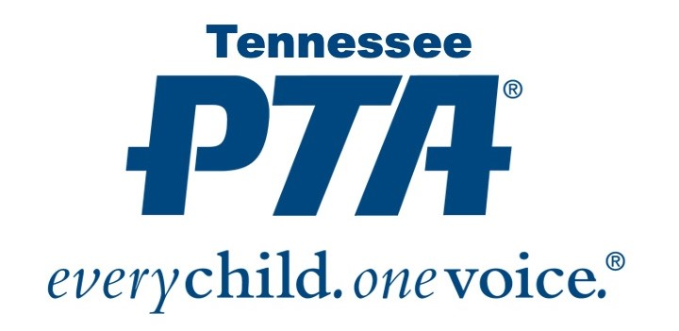

2024-2025 Safety Poster Program Local Unit Entry Inventory

All entries must be submitted via email to [safety@tnpta.org](mailto:safety@tnpta.org) by January 10, 2025. A completed entry form must be submitted with each entry. Questions? Email Health & Safety Chair Rachel Flowers at rflowers@tnpta.org

**Theme: “Healthy Body, Healthy Mind”**

Name of PTA/PTSA:

Council: Region:

President’s Name: Phone:

President’s Email Address:

Name of Chairperson: Phone:

Chairperson’s Email Address:

**EACH LOCAL UNIT MAY SUBMIT THREE ENTRIES** **IN EACH DIVISION**

**Please print or type the information. If not legible, certificates may be incorrect.**

### Division 1 (Preschool)

1. Name Grade
2. Name Grade
3. Name Grade

### Division 2 (Grades K through 2)

1. Name Grade
2. Name Grade
3. Name Grade

### Division 3 (Grades 3 through 5)

1. Name Grade
2. Name Grade
3. Name Grade

### Division 4 (Grades 6 through 8)

1. Name Grade
2. Name Grade
3. Name Grade

### Division 5 (Special Education)

1. Name Grade
2. Name Grade
3. Name Grade

P.O. Box 1026 Hixson, Tennessee 37343

phone: 865.896.4016

email: [ptastateoffice@tnpta.org](mailto:ptastateoffice@tnpta.org) | website: www.tnpta.org